Make Me Work
Jack LaLanne in the 1940’2 and when he was in his 90’s…
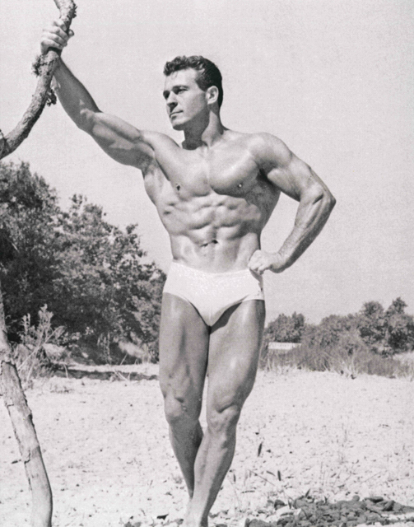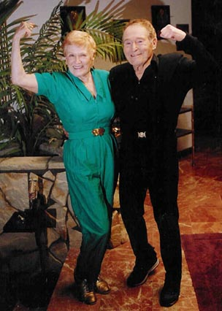
Make Me Work
Arnold Schwarzenegger then and now…
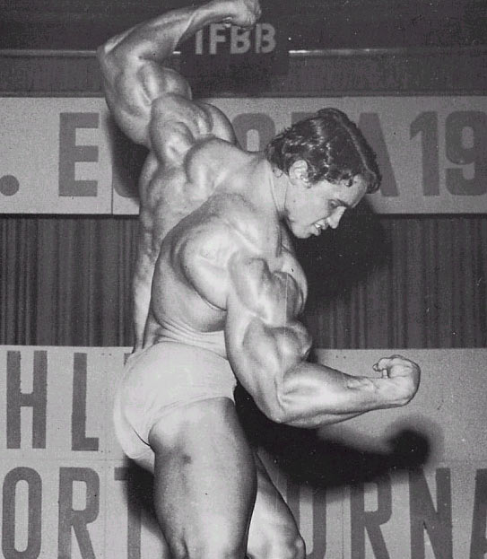
New Year’s get fit resolutions!

Body Areas to Target…
- Chest (Pectoralis)
- Biceps brachii
- Legs (Biceps femoris <hamstring group>, adductors, rectus femoris <quadriceps>)
- Calves (Gastrocnemius and Soleus)
- Back (Latissimus dorsi and Trapezius)
- Abdominal Muscles (External oblique, Internal oblique, Rectus abdominus)
- Triceps (Triceps brachii)
- Shoulders (Deltoid)
- Buttocks (Gluteus maximus)

Please Develop a Workout Routine
- Choose a partner and two target body areas.
- Develop at least 4 exercises, or weight lifting machines that will focus specifically on your target body area.
- Include:
  - Name of the exercise (you may be creative here!)
  - Explain how you perform that exercise.
  - Give the specific muscles that you are working out, when performing the exercise.
  - Agonist and antagonist of the target muscles.
  - Origin and insertion of the target muscles.

Body Area:____________________________________________________
Exercise 1
Name of Exercise:__________________________________________________

How is it done:

What muscles are being worked:

Agonist: Antagonist:

Origin: Insertion:

Exercise 2
Name of Exercise:__________________________________________________

How is it done:

What muscles are being worked:

Agonist: Antagonist:

Origin: Insertion:
Exercise 3
Name of Exercise:__________________________________________________

How is it done:

What muscles are being worked:

Agonist: Antagonist:

Origin: Insertion:

Exercise 4
Name of Exercise:__________________________________________________

How is it done:

What muscles are being worked:

Agonist: Antagonist:

Origin: Insertion:

- After you develop your workout routine you will research and list three supplements that help you build muscle. You must be able to explain how they work.
- You will also research and pick one disease that affects the muscular system and give us the breakdown of the disease. Include:
- Overview of the disease including a description/definition
- Pathophysiology
- Causes/risk factors
- Symptoms
- Diagnosis
- Treatment (include alternative medicine if applicable)
- Prevention
- At least 3 images of the disease
- You will present your information in a power point format
- Final slide must have citations in APA format

